

**Luminar SQL_Assignments:**

Student_name: Manu K Shibu

Batch: ST NOV 2024 B1 Rakhi 2 pm-4pm

**Assignment_1:**

Print the table?

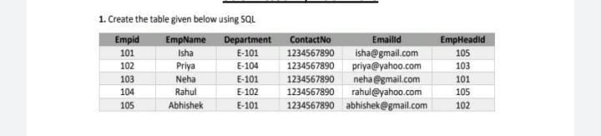

---Assignment-1-----

**CODE:**

create database assignment

use assignment

create table employement1(empid int,empname varchar(10),department varchar(10),contacNo bigint,emailid varchar(30),empheadID int)

insert into employement1 values(101,'isha','E-101',1234567890,'isha@gmail.com',105),(102,'priya','E-104',1234567890,'priya@yahoo.com',103),(103,'neha','E-101',1234567890,'neha@gmail.com',101),(104,'Rahul','E-102',1234567890,'rahul@yahoo.com',105),(105,'Abhishek','E-101',1234567890,'abhishek@gmail.com',102)

select * from employement1

**Output:**

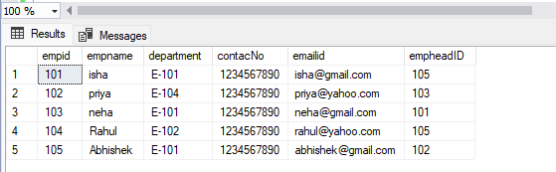

**Assignment_2:**

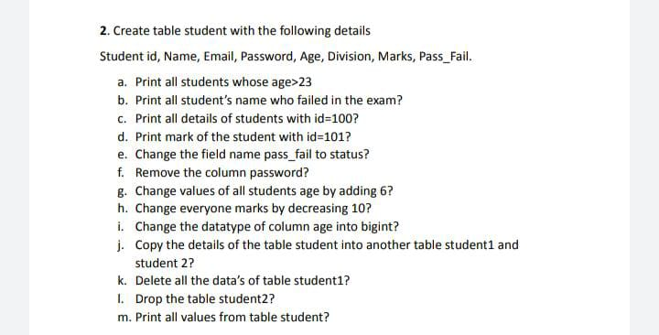

**CODE:**

---Assignment-2-----

create table student(Sudentid int,studentname varchar(10),email varchar(20),password varchar(10),age int,division varchar(5),marks bigint,pass_fail varchar(10))

insert into student values(100,'manu','manu@gmail.com','aswe',21,'A',100,'PASS')

insert into student values(101,'anu','anu@gmail.com','asw55e',22,'B',1,'FAIL')

insert into student values(102,'chanu','chanu@gmail.com','asw44e',23,'C',10,'FAIL')

insert into student values(103,'deki','deki@gmail.com','aswe4',24,'A',50,'PASS')

insert into student values(104,'venki','venki@gmail.com','as4we',25,'D',0,'FAIL')

select * from student

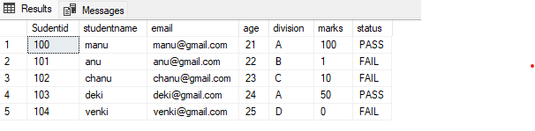

--a--

select * from student where age>23

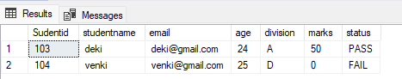

--b--

select * from student where pass_fail='FAIL'

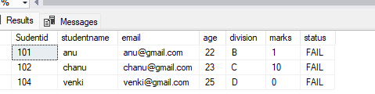

--c--

select * from student where Sudentid=100

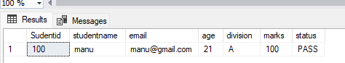

--d--

select marks from student where Sudentid=101

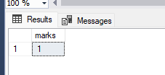

--e--

sp_rename 'student.pass_fail','status','column'

select * from student

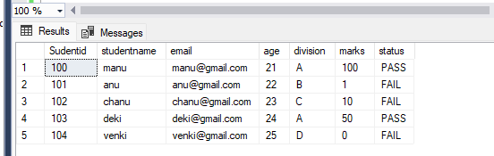

--f--

alter table student drop column password

select * from student

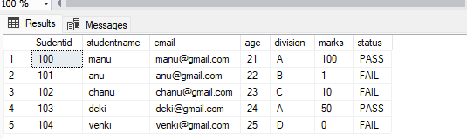

--g--

update student set age+=6

select * from student

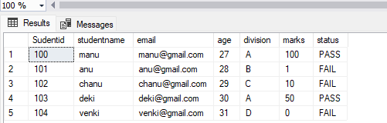

--h--

update student set marks-=10

select * from student

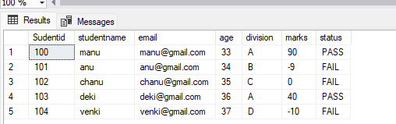

--i--

alter table student alter column age bigint

sp_help student

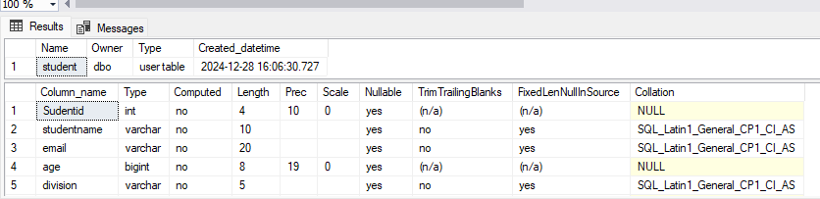

--j--

select * into student1 from student

select * into student2 from student

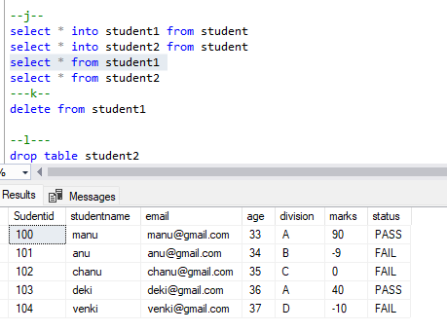

---k--

delete from student1

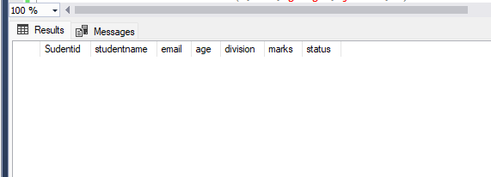

--l---

drop table student2

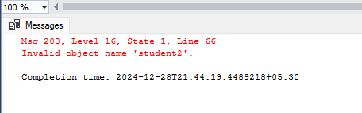

---m---

select * from student

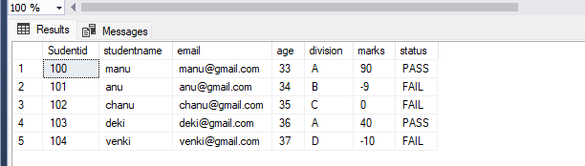

**ASSIGNMENT_3:**

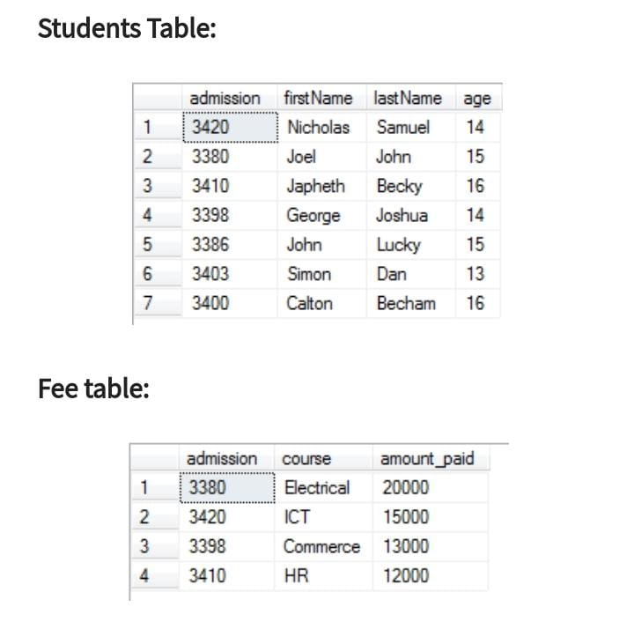

1. Use joins methods and print left/right/inner/full join.

**CODE:**

----Assignment3---

create table studentstable(slno int,admission bigint,firstname varchar(10),lastname varchar(10),age int)

create table feetable(slno int,admission bigint,course varchar(20),amount_paid bigint)

insert into studentstable values(1,3420,'nicholas','samuel',14)

insert into studentstable values(2,3380,'joel','john',15)

insert into studentstable values(3,3410,'japheth','becky',16)

insert into studentstable values(4,3398,'george','joshua',14)

insert into studentstable values(5,3386,'john','lucky',15)

insert into studentstable values(6,3403,'simon','dan',13)

insert into studentstable values(7,3400,'calton','becham',16)

select * from studentstable

insert into feetable values(1,3380,'Electrical',20000)

insert into feetable values(2,3420,'ICT',15000)

insert into feetable values(3,3398,'Commerce',13000)

insert into feetable values(4,3410,'HR',12000)

Select * from feetable

select studentstable.firstname,studentstable.lastname,feetable.course from studentstable inner join feetable on studentstable.admission=feetable.admission

select studentstable.firstname,studentstable.lastname,feetable.course from studentstable left join feetable on studentstable.admission=feetable.admission

select studentstable.firstname,studentstable.lastname,feetable.course from studentstable right join feetable on studentstable.admission=feetable.admission

select studentstable.firstname,studentstable.lastname,feetable.course from studentstable full join feetable on studentstable.admission=feetable.admission

**OUTPUT:**

Inner_join:

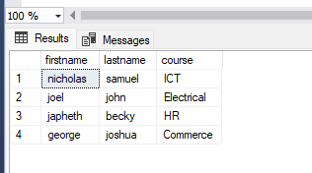

Left_join:

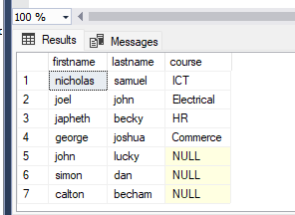

Right_join:

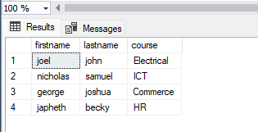

Full_join:

